**Aim:- Programs related to different Layouts.**

1. **Linear Layout**
2. **Vertical Orientation.**

**Activity_Main.XML Code:-**

*<?*xml version="1.0" encoding="utf-8"*?>*<LinearLayout xmlns:android="http://schemas.android.com/apk/res/android"  
 xmlns:app="http://schemas.android.com/apk/res-auto"  
 xmlns:tools="http://schemas.android.com/tools"  
 android:layout_width="match_parent"  
 android:layout_height="match_parent"  
 android:orientation="vertical"  
 tools:context=".MainActivity">  
  
 <TextView  
 android:layout_width="387dp"  
 android:layout_height="120dp"  
 android:layout_marginTop="200dp"  
 android:text="SPKCollege"  
 android:textAlignment="center"  
 android:textColor="@color/black"  
 android:textSize="70dp"  
 app:layout_constraintBottom_toBottomOf="parent"  
 app:layout_constraintEnd_toEndOf="parent"  
 app:layout_constraintStart_toStartOf="parent"  
 app:layout_constraintTop_toTopOf="parent" />  
  
 <TextView  
 android:id="@+id/textView3"  
 android:layout_width="324dp"  
 android:layout_height="88dp"  
 android:layout_marginLeft="20dp"  
 android:layout_marginTop="200dp"  
 android:layout_marginBottom="50dp"  
 android:layout_weight="1"  
 android:text="TY.BSC.IT"  
 android:textAlignment="center"  
 android:textSize="70dp"  
 android:translationZ="20dp" />  
  
  
</LinearLayout>

**Output:-**

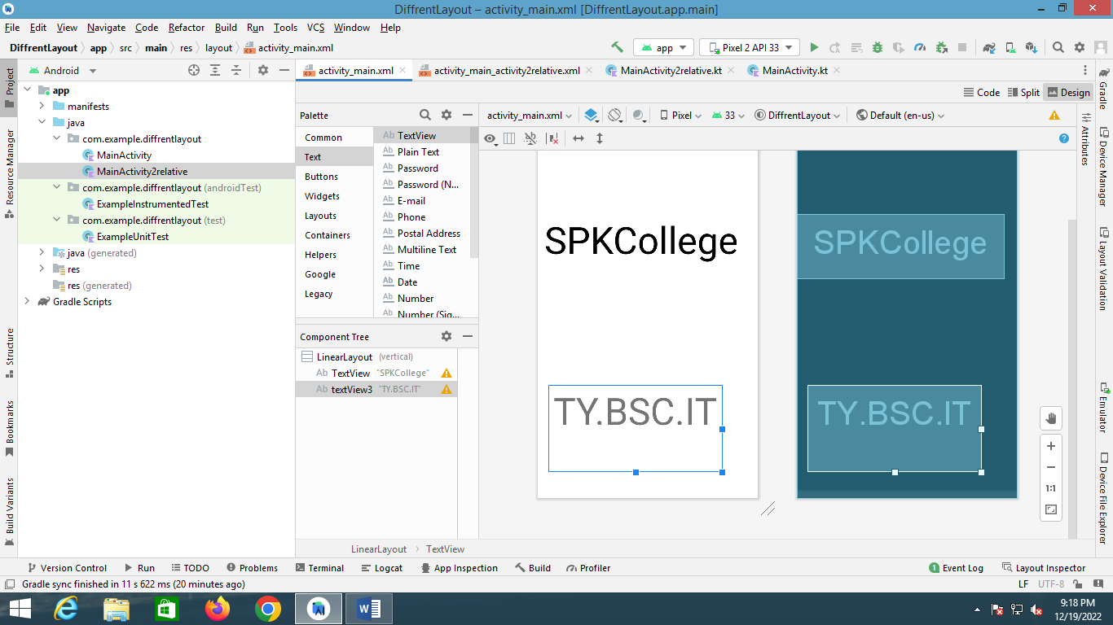

1. **Horizontal Orientation:-**

**Activity_Main.XML Code:-**

*<?*xml version="1.0" encoding="utf-8"*?>*<LinearLayout xmlns:android="http://schemas.android.com/apk/res/android"  
 xmlns:app="http://schemas.android.com/apk/res-auto"  
 xmlns:tools="http://schemas.android.com/tools"  
 android:layout_width="match_parent"  
 android:layout_height="match_parent"  
 android:orientation="horizontal"  
 tools:context=".MainActivity">  
  
 <TextView  
 android:layout_width="189dp"  
 android:layout_height="43dp"  
 android:layout_marginTop="200dp"  
 android:text="SPKCollege"  
 android:textAlignment="center"  
 android:textColor="@color/black"  
 android:textSize="20dp"  
 app:layout_constraintBottom_toBottomOf="parent"  
 app:layout_constraintEnd_toEndOf="parent"  
 app:layout_constraintStart_toStartOf="parent"  
 app:layout_constraintTop_toTopOf="parent" />  
  
 <TextView  
 android:id="@+id/textView3"  
 android:layout_width="9dp"  
 android:layout_height="91dp"  
 android:layout_marginLeft="20dp"  
 android:layout_marginTop="500dp"  
 android:layout_marginBottom="100dp"  
 android:layout_weight="1"  
 android:text="TY.BSC.IT"  
 android:textAlignment="center"  
 android:textSize="30dp"  
 android:translationZ="20dp" />  
  
  
</LinearLayout>

**Output:-**

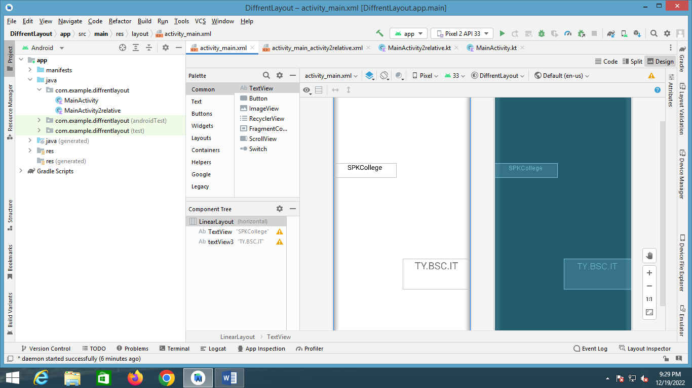

1. **Relative Layout:-**

**Activity_Main.XML Code:-**

*<?*xml version="1.0" encoding="utf-8"*?>*<RelativeLayout xmlns:android="http://schemas.android.com/apk/res/android"  
 xmlns:app="http://schemas.android.com/apk/res-auto"  
 xmlns:tools="http://schemas.android.com/tools"  
 android:layout_width="match_parent"  
 android:layout_height="match_parent"  
 tools:context=".MainActivity2relative">  
  
 <TextView  
 android:id="@+id/textView"  
 android:layout_width="wrap_content"  
 android:layout_height="wrap_content"  
 android:layout_alignParentTop="true"  
 android:layout_alignParentEnd="true"  
 android:layout_alignParentBottom="true"  
 android:layout_marginTop="68dp"  
 android:layout_marginEnd="10dp"  
 android:layout_marginBottom="570dp"  
 android:text="SPK College"  
 android:textColor="@color/black"  
 android:textAlignment="center"  
 android:textSize="70dp" />  
  
 <TextView  
 android:id="@+id/textView2"  
 android:layout_width="wrap_content"  
 android:layout_height="wrap_content"  
 android:layout_alignParentStart="true"  
 android:layout_alignParentTop="true"  
 android:layout_alignParentEnd="true"  
 android:layout_alignParentBottom="true"  
 android:layout_marginStart="58dp"  
 android:layout_marginTop="380dp"  
 android:layout_marginEnd="47dp"  
 android:layout_marginBottom="258dp"  
 android:text="TY.BSC.IT"  
 android:textColor="@color/purple_200"  
 android:textAlignment="center"  
 android:textSize="70dp" />  
  
  
</RelativeLayout>

**Output:-**

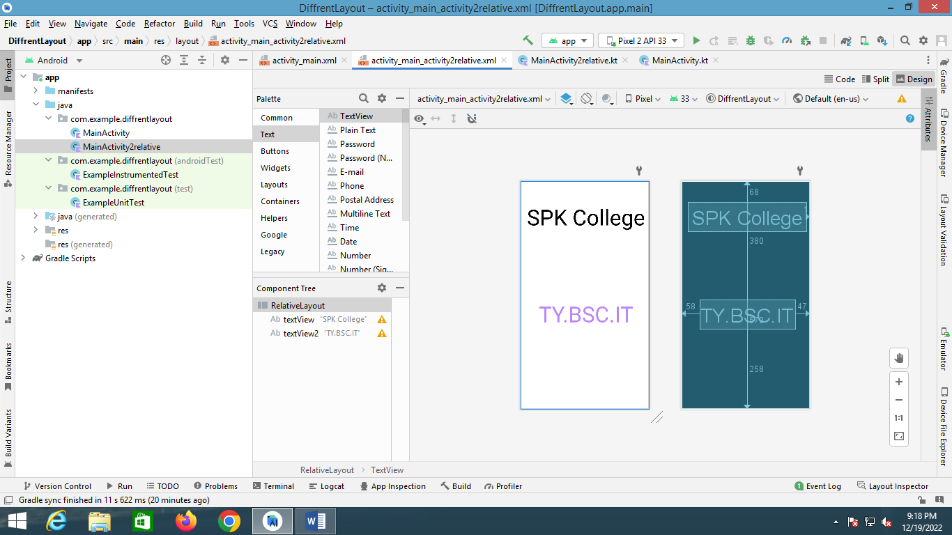

1. **Table Layout:-**

**Activity_Main.XML Code:-**

*<?*xml version="1.0" encoding="utf-8"*?>*<LinearLayout xmlns:android="http://schemas.android.com/apk/res/android"  
 xmlns:app="http://schemas.android.com/apk/res-auto"  
 xmlns:tools="http://schemas.android.com/tools"  
 android:layout_width="match_parent"  
 android:layout_height="match_parent"  
 tools:context=".MainActivity">  
  
 <TableLayout  
 android:layout_width="400dp"  
 android:layout_height="300dp"  
 android:layout_marginLeft="20dp">  
  
  
 <TableRow>  
 <Button  
 android:text="1"  
 android:textSize="30dp"  
 android:layout_margin="10dp"  
 android:width="100dp">  
  
 </Button>  
 <Button  
 android:text="2"  
 android:textSize="30dp"  
 android:layout_margin="10dp"  
 android:width="100dp">  
  
 </Button>  
 <Button  
 android:text="3"  
 android:textSize="30dp"  
 android:layout_margin="10dp"  
 android:width="100dp">  
  
 </Button>  
 </TableRow>  
  
 <TableRow>  
 <Button  
 android:text="4"  
 android:textSize="30dp"  
 android:layout_margin="10dp"  
 android:width="100dp">  
  
 </Button>  
 <Button  
 android:text="5"  
 android:textSize="30dp"  
 android:layout_margin="10dp"  
 android:width="100dp">  
  
 </Button>  
 <Button  
 android:text="6"  
 android:textSize="30dp"  
 android:layout_margin="10dp"  
 android:width="100dp">  
  
 </Button>  
 </TableRow>  
  
 <TableRow>  
 <Button  
 android:text="7"  
 android:textSize="30dp"  
 android:layout_margin="10dp"  
 android:width="100dp">  
  
 </Button>  
 <Button  
 android:text="8"  
 android:textSize="30dp"  
 android:layout_margin="10dp"  
 android:width="100dp">  
  
 </Button>  
 <Button  
 android:text="9"  
 android:textSize="30dp"  
 android:layout_margin="10dp"  
 android:width="100dp">  
  
 </Button>  
 </TableRow>  
  
 </TableLayout>  
</LinearLayout>

**Output:-**

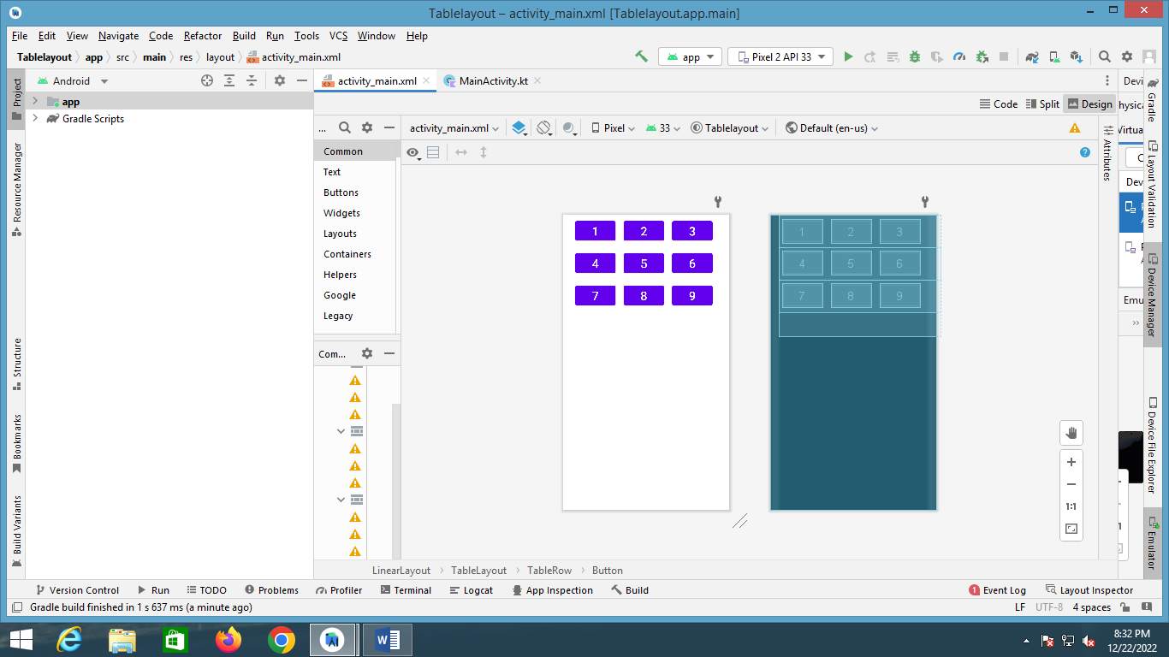

1. **Grid Layout:-**

**Activity_Main.XML Code:-**

*<?*xml version="1.0" encoding="utf-8"*?>*<GridLayout xmlns:android="http://schemas.android.com/apk/res/android"  
 xmlns:app="http://schemas.android.com/apk/res-auto"  
 xmlns:tools="http://schemas.android.com/tools"  
 android:layout_width="match_parent"  
 android:layout_height="match_parent"  
 tools:context=".MainActivity">  
  
  
 <TextView  
 android:id="@+id/textView"  
 android:layout_width="120dp"  
 android:layout_height="60dp"  
 android:layout_marginLeft="10dp"  
 android:layout_row="0"  
 android:layout_column="0"  
 android:text="Aviraj"  
 android:textColor="@color/purple_200"  
 android:textSize="40dp"/>  
  
 <TextView  
 android:id="@+id/textView2"  
 android:layout_width="120dp"  
 android:layout_height="60dp"  
 android:layout_marginLeft="10dp"  
 android:layout_row="0"  
 android:text="Aniket"  
 android:textColor="@color/black"  
 android:textSize="40dp" />  
  
 <TextView  
 android:id="@+id/textView3"  
 android:layout_marginLeft="10dp"  
 android:layout_width="120dp"  
 android:layout_height="60dp"  
 android:layout_row="0"  
 android:text="Kapil"  
 android:textColor="@color/purple_700"  
 android:textSize="40dp" />  
  
  
</GridLayout>

**Output:-**

